**Sequence Diagram: Event Announcements**

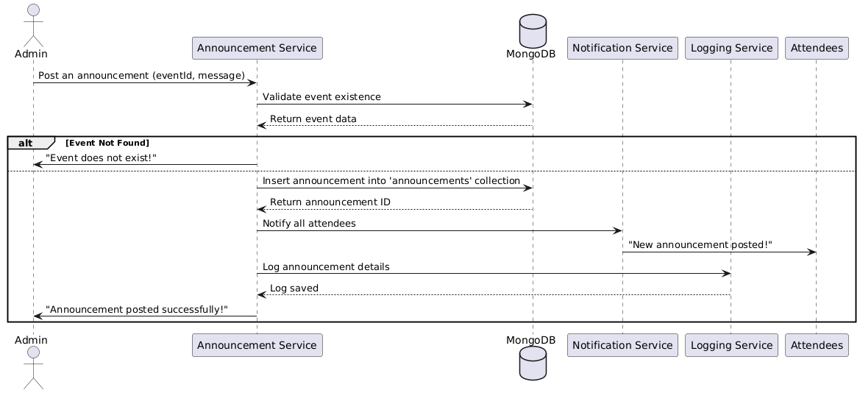

**Database**

**Functional Requirements (FRs)**

* **FR1:** The system shall allow group admins to post announcements for events.
* **FR2**: Announcements shall be visible to all registered attendees of the event.
* **FR3:** The system shall send notifications to attendees upon announcement creation.
* **FR4:** The system shall allow users to view past announcements related to an event.

**Non-Functional Requirements (NFRs)**

* **NFR1**: Announcements should be delivered within 5 seconds after posting.
* **NFR2:** The system shall store announcements for a minimum of one year for reference.